The HR Agency Appreciation User Manual

1.) lOGIN Page 1
2.) APPRECIATION Page 2
3.) cARd Upload Page 5
4.) Client list Page 6
5.) Add Client Form Page 6
6.) Edit Client Form Page 8
7.) client info Page 10
8.) DELETE 12
9.) Appendix 13

- Login Page

To start to use the system, a client needs to log in, using the screen below:

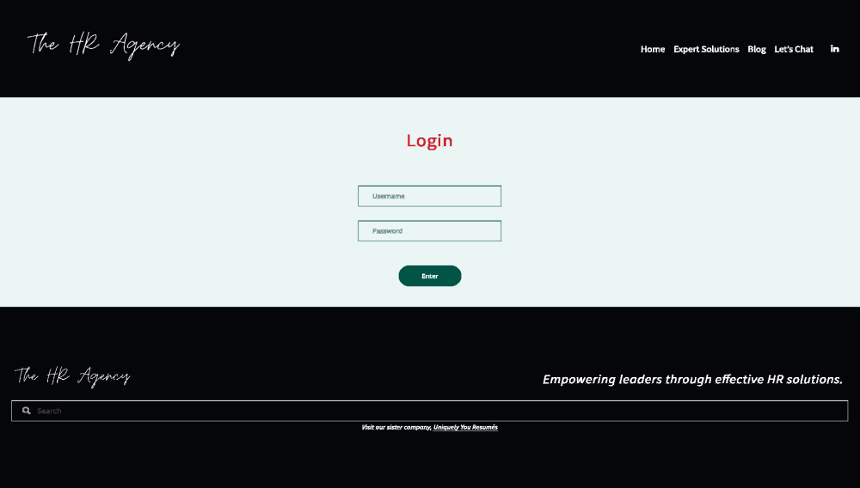
The user needs only to enter their company email address and their assigned password in the correct fields and click “Enter”.

- Appreciation Page

To use Appreciation page correctly user needs to perform the following steps:

- Once a User is logged in, the only page they will see is the Appreciation Page, to which they are automatically directed. Then, the user will select the card they want to send. Users can also filter the images/cards they’d like to send based on the categories.

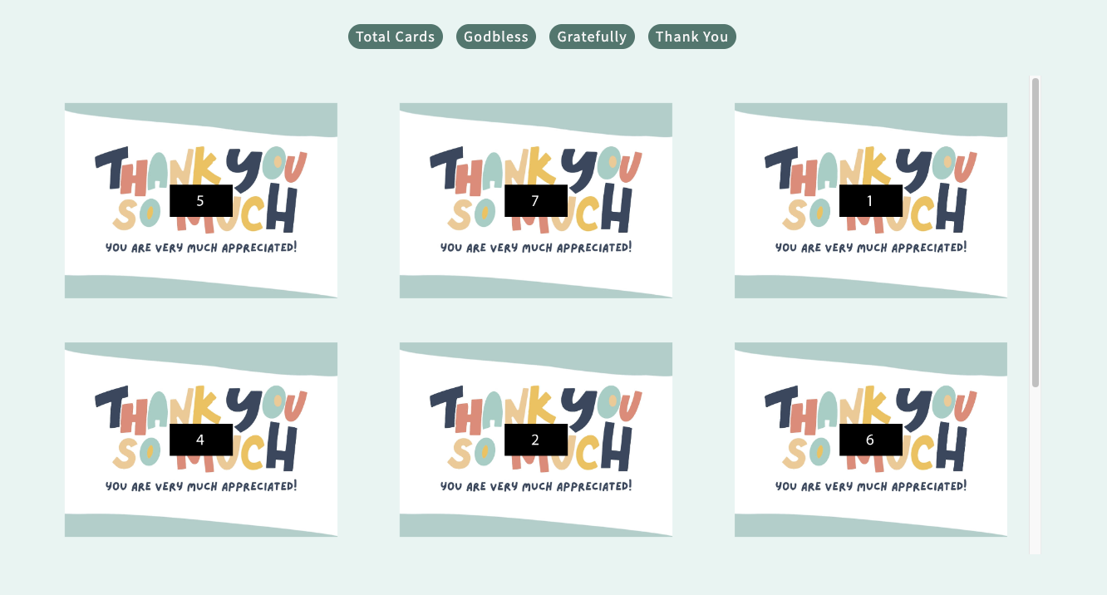

- As soon as the User selects the card, the card displays just below Appreciation card display section. 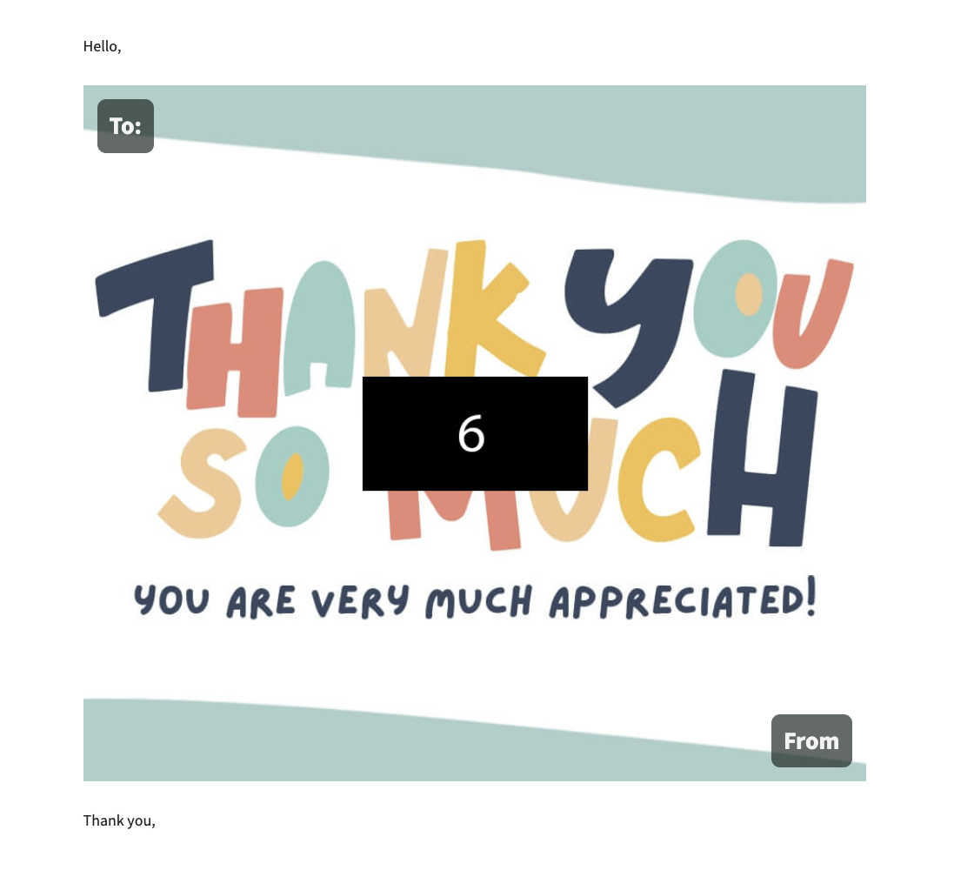
- The information the User types in is automatically displayed as they fill out the form and gives them a first look as to how the card is going to look before they send it.

- All the fields in the form are required. If any field is kept empty or if an incorrectly formatted email address is inserted, the cursor automatically scrolls up to that input field to allow the User an opportunity to correct the mistake. (Following page).

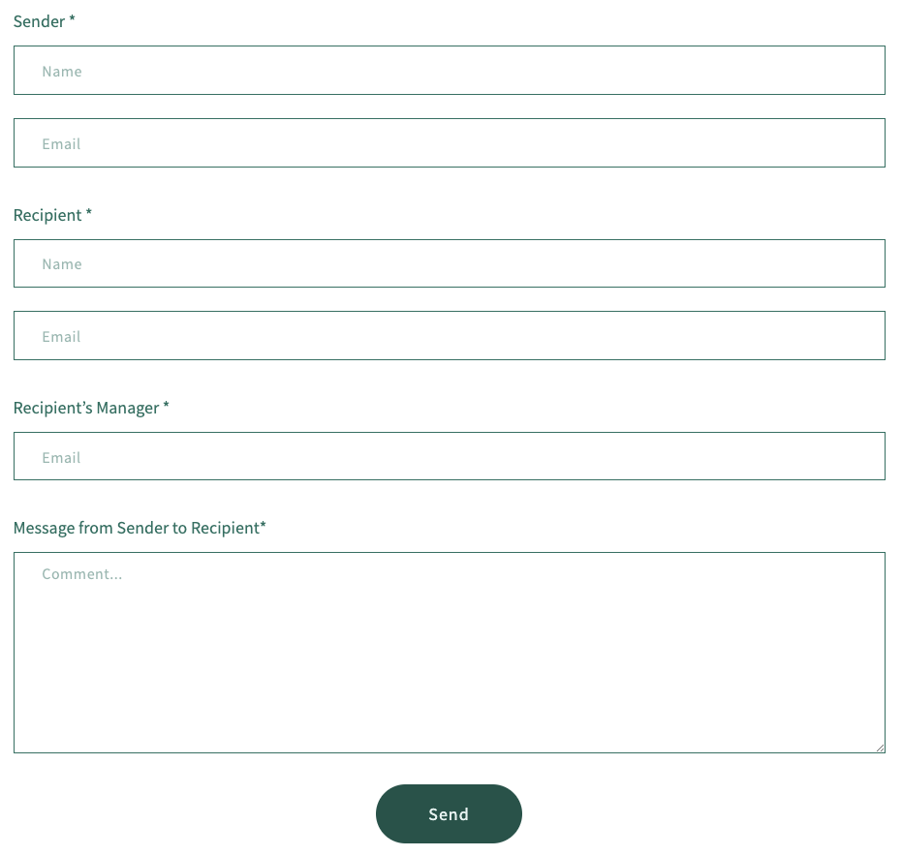

- The email is sent to the recipient and CC’d to the recipient’s Manager once the ‘Send’ button is clicked.

- Card-Upload Page

Steps to upload a Card.

- User needs to click the “Choose File” button to choose the ‘.jpg’ file to upload the card. Once the “Choose File” button is clicked, another window will open, allowing you to search through your computer to find and select the card you wish to upload to the site.

- If you wish to categorize a card and upload it in the ‘Thank You’ category, the user has to rename the file and append a hyphen (“-“) followed by the name of the category. For example, if there is a file name ‘card.jpg’, and the user wants to upload the card in ‘thank you’ category, user must rename it as ‘card-thank you.jpg’. Please be advised that the system will ONLY accept files with the “.jpg” extension.

- Initially the “Upload Card” button is greyed, meaning that the button is disabled. The button will become active only if the correct file format is chosen.
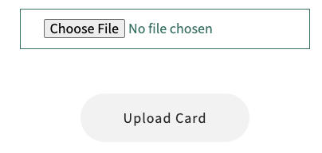
- Once a card with the proper extension is selected, the “Upload Card” button will change color becoming green, indicating that it is now active.
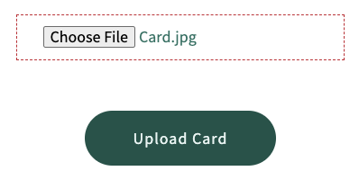

- Client List Page

To see a few details of all the companies in the database, you must first go to the “Admin” menu on the top right corner of the page, and select “Client Info” (see screenshot below). This will display all the companies in the database, including a count of the total number of companies currently in the database.

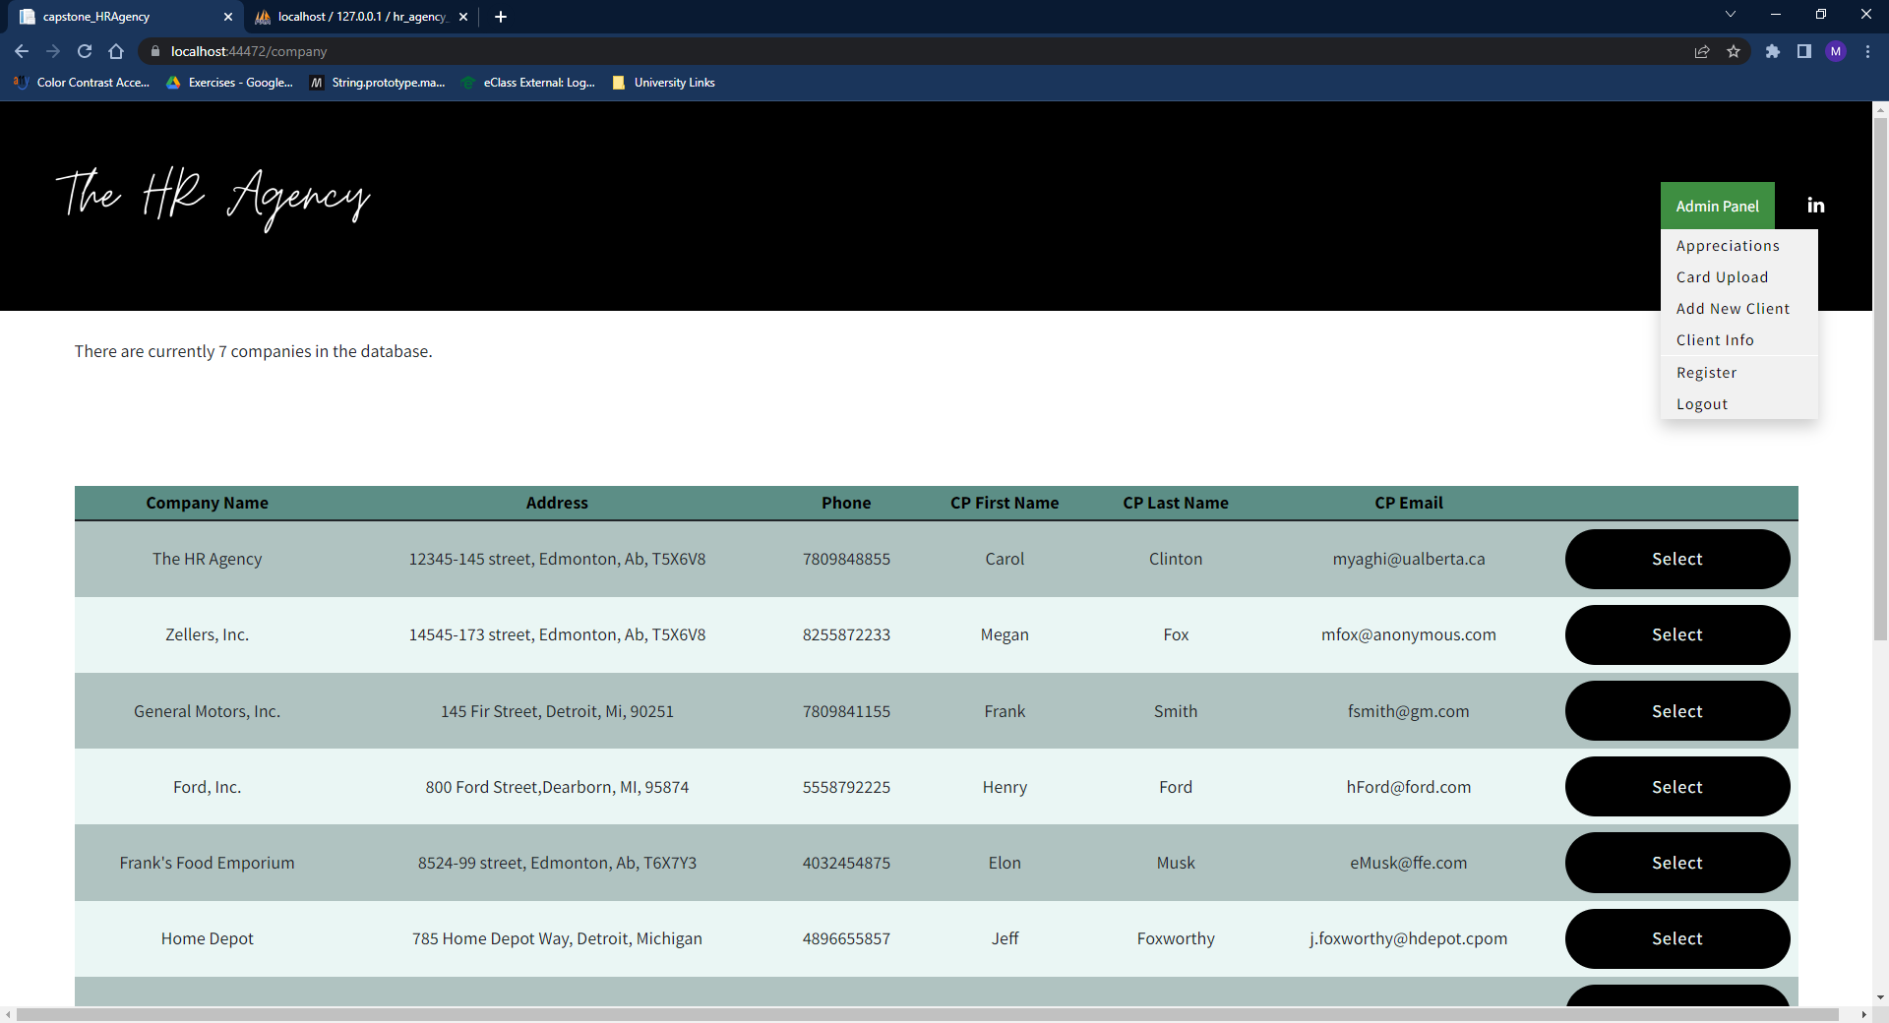

Add Client Form Page

Adding a new client to the database is a straightforward operation. Just fill in the fields, and then click on the “Add Client” button on the bottom of the page. It should be noted that there is substantial automatic data-entry verification of the form, to ensure that any data entered is, in fact, valid data. That being said however, it is impossible to verify for every possibility for every field. There are certain provisions however that have been added to the date selection fields. Namely, the “Start Date” cannot be a date in the past; it must be equal to the date you are entering the new client, or sometime in the future. Also, it will not allow you to enter an “End Date” before the “Start Date”. With regards to the “Permission Level” drop-down, the only person/organization that has “Full Admin Access” is you, the owner. Everyone else is assigned “Client Level Access” only (unless you, the owner, decide otherwise). This is to ensure that no one other than the owner has access to sensitive companies’ information and is able to add/edit or delete clients, or change their access level to the site.
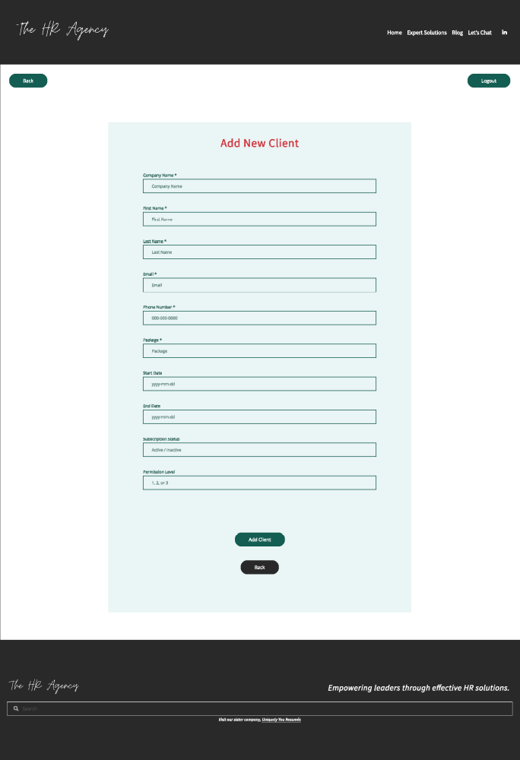
- Edit Client Form Page

The “Edit Client Form Page” (next page) is accessed from the “Company List Page” (below). On that page, when a company is selected, all of its relevant information is pre-populated in their respective fields automatically when the page loads. This is for the ease of use of the user. Simply select the fields/information that you want to change/update, then at the bottom of the page, click on “Accept Changes”, and the changes will be saved to the database. All the error-checking and data input validation that is on the “Add Client Page” is also implemented on the “Edit” page, but with one major exception: it does not force you to enter a date equal to your current date or in the future, since the company you are editing may have been a client for several months, or even years.

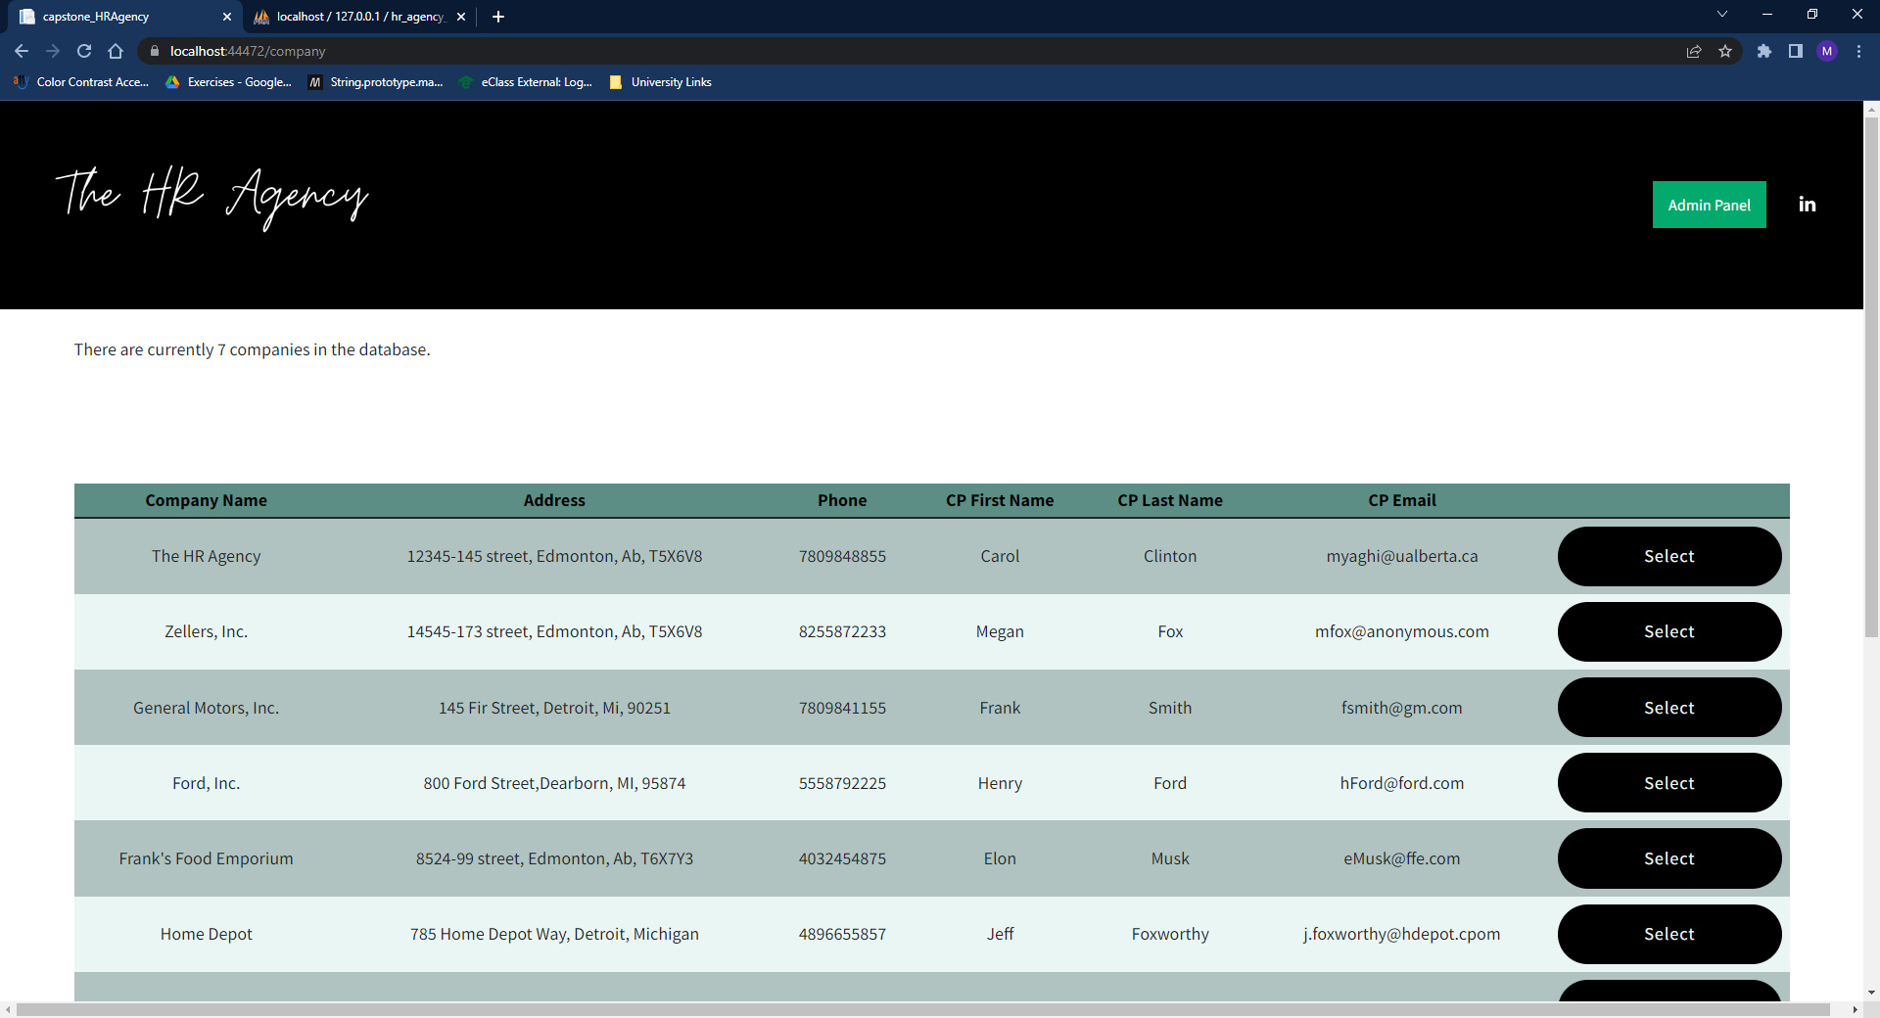
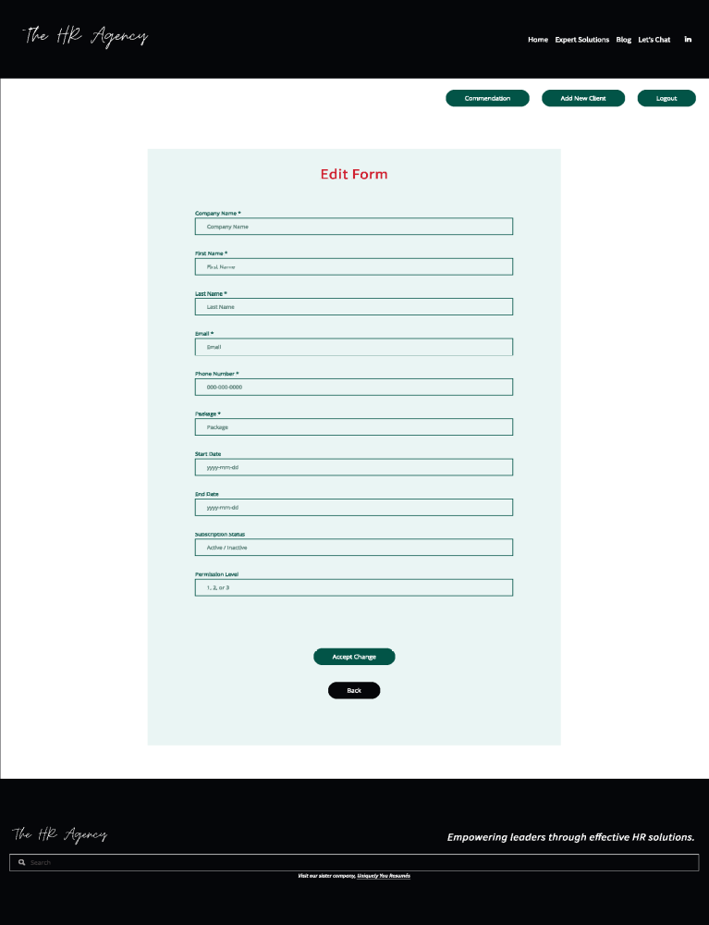

- Client Info Page

To see the full details of a given company, you must first go to the “Admin” menu on the top right corner of the page, and select “Client Info” (see screenshot below).

That will bring you to the “Client Detail Screen” below:

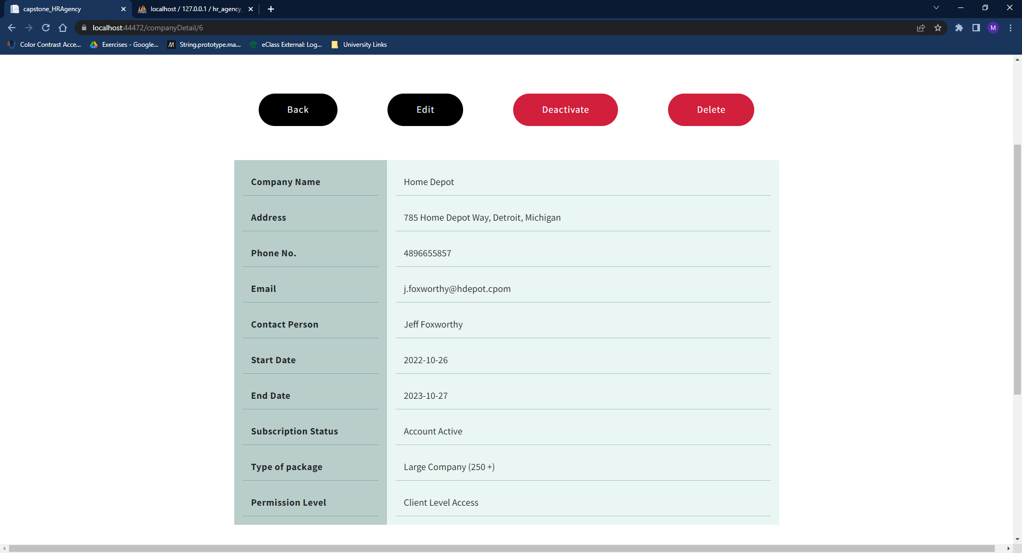

At the top of the screen there are 4 buttons; “Back”, “Edit”, “Deactivate” and “Delete”. The “Back” button returns you to the previous screen; the “Edit” button takes you to the “Edit Client” screen discussed above. The “Deactivate” button allows you to activate/enable or deactivate/disable a client’s access to the Appreciations! screen, and in essence, allow/prevent their use of the site. It must be noted that in the photo above, on the 8th row – 1st column, there is the “Subscription Status”, and next to it in the 2nd column, the words “Account Active”. This can be updated/controlled from this page, without needing to go to the “Edit Client” page. Simply click on the red “Deactivate” button, and it will automatically update the company’s Subsctiption Status in the database, update the page itself to read “Account Active”, and also change the red “Deactivate” button to a green colored “Activate” button as shown in the next image:

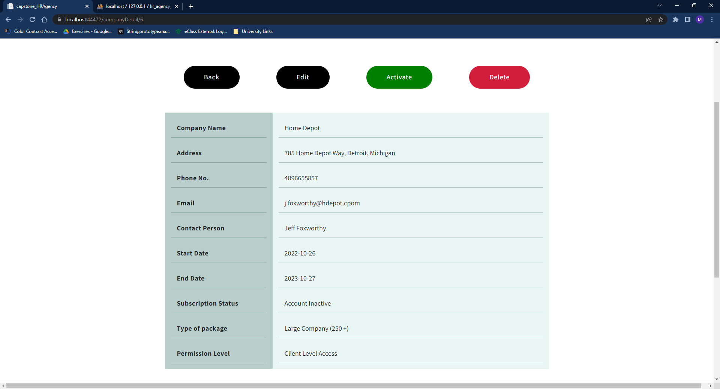

- Delete

The red colored “Delete” button at the top right of the screen (above) will delete the company that is currently displayed on screen. Once the “Delete” button is pressed, a confirmation dialog box will appear on screen, asking you to confirm whether or not you really want to delete the company. This is designed to add another level of error-prevention, to minimize the possibility that a company might be deleted accidentally. If you click “Ok”, the program will delete the company from the database, clear the screen, then automatically take you back to the “Company List” screen. If you click “Cancel”, the dialog box will disappear and nothing will be deleted.

- Appendix

The following libraries were installed to build/run the system.

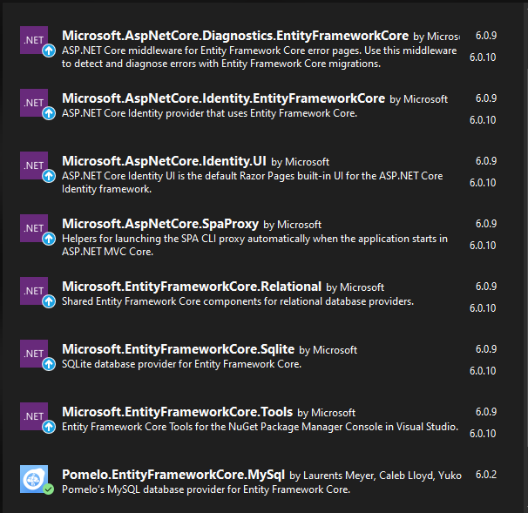

Additionally, the following commands need to be run from the Package Manager Console to build the project, the migration and database (in order of operation):
- dotnet build
- dotnet ef migrations add $NAME
- dotnet ef database update
If needed, you can use the command: ‘dotnet ef migrations remove’, then start over.

